






GST NO.: 29AHZPU5620Q1ZZ
ROYAL INDUSTRIAL SUPPLIERS
An ISO 9001:2015 Certified Company

QUALITY FASTENERS SPECIALIST



8310165941 / 9959457863 sales@royalfastenersindia.com www.royalfastenersindia.com

TECHNICAL DATA SHEET

SELF CLINCHING THROUGH HOLE STANDOFF (SOS)


MATERIAL- STAINLESS STEEL

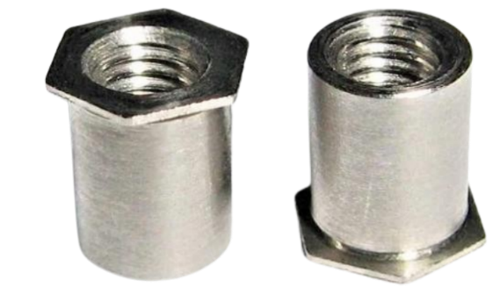
GRADE-SS304 (A2)

AS PER-NON-STANDARD

CATALOGUE NO. R4S19


INSTALLATION GUIDE
- VERIFY THE STANDOFF SIZE, LENGTH, THREAD TYPE, AND MATERIAL MATCH THE APPLICATION REQUIREMENT.
- ENSURE THE BASE MATERIAL IS DUCTILE AND SUITABLE FOR SELF CLINCHING INSTALLATION.
- PUNCH OR DRILL THE MOUNTING HOLE TO THE SPECIFIED DIAMETER AND TOLERANCE.
- CONFIRM THE HOLE IS ROUND, CLEAN, AND FREE FROM BURRS OR CONTAMINATION.
- INSERT THE SELF CLINCHING STANDOFF INTO THE HOLE FROM THE SPECIFIED INSTALLATION SIDE.
- ENSURE THE STANDOFF HEAD IS FLUSH AGAINST THE BASE MATERIAL SURFACE BEFORE PRESSING.
- USE A FLAT, PARALLEL PRESS TOOL OR HYDRAULIC PRESS FOR INSTALLATION.
- APPLY STEADY, AXIAL PRESS FORCE WITHOUT ROTATION.
- ALLOW THE BASE MATERIAL TO FLOW INTO THE STANDOFF’S UNDERCUT GROOVE.
- DO NOT HAMMER OR APPLY IMPACT FORCE DURING INSTALLATION.
- VERIFY THE STANDOFF SHOULDER IS FULLY SEATED AND FLUSH WITH THE MATERIAL SURFACE.
- CHECK THAT THE THROUGH HOLE IS CLEAR AND FREE FROM DISTORTION.
- CONFIRM THE STANDOFF DOES NOT SPIN OR PULL OUT AFTER INSTALLATION.
- AVOID OVER-PRESSING TO PREVENT PANEL DISTORTION OR STANDOFF DAMAGE.
- INSPECT THE FINAL ASSEMBLY FOR ALIGNMENT, HOLDING STRENGTH, AND SURFACE FLATNESS.

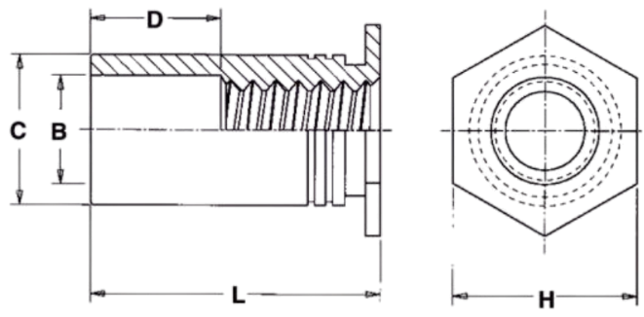

Size |  | M2x0.4 | M2.5x0.45 | M3x0.5 | 3.5M3x0.5 | M3.5x0.6 | M4x0 .7 | M5x0.8
C -0.13 |  | 4.20 | 4.20 | 4.20 | 5.39 | 5.39 | 7.12 | 7.12
H nom |  | 4.80 | 4.80 | 4.80 | 6.40 | 6.40 | 7.90 | 7.90
Counter bore dia B ±0.13 |  | 3.20 | 3.20 | 3.20 | 3.20 | 3.90 | 4.80 | 5.35
Hole Size in Sheet +0.08 |  | 4.22 | 4.22 | 4.22 | 5.41 | 5.41 | 7.14 | 7.14
Min sheet thickness |  | 1.02 | 1.02 | 1.02 | 1.02 | 1.02 | 1.27 | 1.27
Min Dist. Hole C/L to edge |  | 6.00 | 6.00 | 6.00 | 6.80 | 6.80 | 8.00 | 8.00
Max tightening torque for  mating screw Nm |  | 0.20 | 0.20 | 0.40 | 0.40 | 0.70 | 1.40 | 2.60
Installation KN | 5052-H34 AL | 4.80 | 4.80 | 4.80 | 7.50 | 7.50 | 10.60 | 10.60
Installation KN | Cold Rolled Sheet | 9.60 | 9.60 | 9.60 | 14.50 | 14.50 | 17.60 | 17.60
Pushout N | 5052-H34 AL | 700 | 700 | 700 | 1300 | 1300 | 1750 | 1750
Pushout N | Cold Rolled Sheet | 1000 | 1000 | 1000 | 1860 | 1860 | 2480 | 2480
Torque Out NM | 5052-H34 AL | 1.02 | 1.02 | 1.24 | 1.24 | 2.82 | 5.08 | 5.08
Torque Out NM | Cold Rolled Sheet | 1.95 | 1.95 | 2.15 | 2.15 | 3.90 | 8.40 | 8.40

Quote the PART NUMBER given below with your order/ inquiries: All Dimensions in mm

D ±0.5 | Dia→ Length↓ | M2x0.4 | M2.5x0.45 | M3x0.5 | 3.5M3x0.5 | M3.5x0.6 | M4x0 .7 | M5x0.8
 | 3 | R4S1902003 | R4S1920503 | R4S1903003 | R4S1903103 |  | R4S1904003
 | 4 | R4S1902004 | R4S1920504 | R4S1903004 | R4S1903104 | R4S1930504 | R4S1904004 | R4S1905004
 | 5 | R4S1902005 | R4S1920505 | R4S1903005 | R4S1903105 | R4S1930505 | R4S1904005 | R4S1905005
 | 6 | R4S1902006 | R4S1920506 | R4S1903006 | R4S1903106 | R4S1930506 | R4S1904006 | R4S1905006
 | 8 | R4S1902008 | R4S1920508 | R4S1903008 | R4S1903108 | R4S1930508 | R4S1904008 | R4S1905008
4.00 | 10 | R4S1902010 | R4S1920510 | R4S1903010 | R4S1903110 | R4S1930510 | R4S1904010 | R4S1905010
4.00 | 12 | R4S1902012 | R4S1920512 | R4S1903012 | R4S1903112 | R4S1930512 | R4S1904012 | R4S1905012
4.00 | 14 | R4S1902014 | R4S1920514 | R4S1903014 | R4S1903114 | R4S1930514 | R4S1904014 | R4S1905014
8.00 | 16 | R4S1902016 | R4S1920516 | R4S1903016 | R4S1903116 | R4S1930516 | R4S1904016 | R4S1905016
8.00 | 18 |  |  | R4S1903018 | R4S1903118 | R4S1930518 | R4S1904018 | R4S1905018
8.00 | 20 |  |  | R4S1903020 | R4S1903120 | R4S1930520 | R4S1904020 | R4S1905020
11.00 | 22 |  |  | R4S1903022 | R4S1903122 | R4S1930522 | R4S1904022 | R4S1905022
11.00 | 25 |  |  | R4S1903025 | R4S1903125 | R4S1930525 | R4S1904025 | R4S1905025
11.00 | 30 |  |  | R4S1903030 | R4S1903130 | R4S1930530 | R4S1904030 | R4S1905030
11.00 | 35 |  |  | R4S1903035 | R4S1903135 | R4S1930535 | R4S1904035 | R4S1905035
11.00 | 40 |  |  | R4S1903040 | R4S1903140 | R4S1930540 | R4S1904040 | R4S1905040
 |  | Length Tolerance +0.05 -0.13
Sizes in BLUE are non-preferred. Availability is limited and MOQ is applied Data is strictly informative

