






GST NO.: 29AHZPU5620Q1ZZ
ROYAL INDUSTRIAL SUPPLIERS
An ISO 9001:2015 Certified Company

QUALITY FASTENERS SPECIALIST



8310165941 / 9959457863 sales@royalfastenersindia.com www.royalfastenersindia.com

TECHNICAL DATA SHEET


EYE BOLT


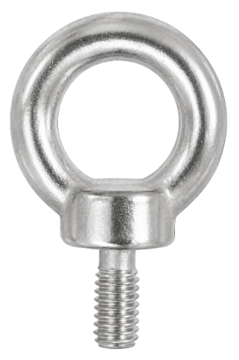
MATERIAL- STAINLESS STEEL

GRADE-SS304 (A2-70)

AS PER-DIN-580

CATALOGUE NO. R4G70


INSTALLATION GUIDE

- SELECT THE CORRECT SIZE AND TYPE OF EYE BOLT BASED ON LOAD REQUIREMENTS AND THREAD SIZE.
- ENSURE THE MOUNTING SURFACE OR MATERIAL IS CLEAN, FLAT, AND STRUCTURALLY STRONG ENOUGH TO HANDLE THE LOAD.
- VERIFY THAT THE THREADS OF THE EYE BOLT AND THE MATING HOLE ARE CLEAN AND FREE FROM RUST, DUST, OR DEBRIS.
- INSERT THE EYE BOLT INTO THE THREADED HOLE OR THROUGH-HOLE DEPENDING ON THE DESIGN.
- HAND-TIGHTEN THE EYE BOLT CLOCKWISE UNTIL IT CONTACTS THE MATING SURFACE.
- USE A SPANNER OR WRENCH ONLY ON THE SHANK FLATS (IF PROVIDED) AND NEVER ON THE EYE, TO AVOID DEFORMATION.
- IF USING A THROUGH-HOLE EYE BOLT, SECURE IT WITH A WASHER AND NUT ON THE OPPOSITE SIDE.
- APPLY THE RECOMMENDED TORQUE USING A TORQUE WRENCH ACCORDING TO LOAD AND SAFETY STANDARDS.
- ALIGN THE EYE PROPERLY IN THE DIRECTION OF THE LOAD TO PREVENT BENDING OR FAILURE.
- ENSURE THAT THE LOAD IS APPLIED IN LINE WITH THE PLANE OF THE EYE AND NEVER SIDEWAYS.
- CHECK THAT THE EYE BOLT IS FULLY SEATED, STRAIGHT, AND FREE FROM MOVEMENT.
- DO NOT EXCEED THE WORKING LOAD LIMIT SPECIFIED BY THE MANUFACTURER.
- INSPECT THE FINAL INSTALLATION TO CONFIRM A SAFE, STABLE, AND RELIABLE CONNECTION.

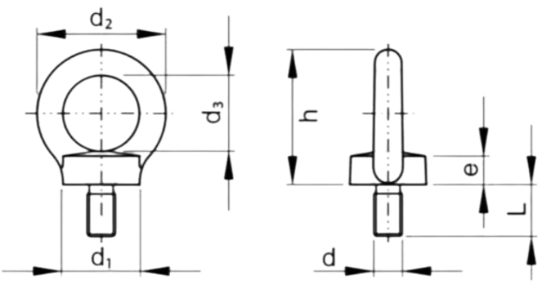

Note: Factor of safety is 6

Quote the PART NUMBER given below with your order/ inquiries: All Dimensions in mm

Nominal Size (d) | PART NUMBER | Stem  Length | Eye-ID | Height | Collar  Dia | Collar  Height | Eye-OD | WLL Kgs
Thread Size | PART NUMBER | L | d3 | h | d1 | e | d2 | T
M6x1.0 | R4G7006000 | 12 | 19.50 | 36.00 | 19.00 | 9.00 | 34.00 | 100.00
M8x1.25 | R4G7008000 | 13 | 19.50 | 36.00 | 19.00 | 9.00 | 34.00 | 140.00
M10x1.5 | R4G7010000 | 17 | 24.00 | 44.00 | 24.50 | 10.00 | 41.00 | 230.00
M12x1.75 | R4G7012000 | 20 | 28.00 | 52.00 | 29.00 | 11.00 | 50.00 | 240.00
M14x2.0 | R4G7014000 | 27 | 33.00 | 62.00 | 35.00 | 12.00 | 60.00 | 600.00
M16x2.0 | R4G7016000 | 27 | 33.00 | 62.00 | 35.00 | 12.00 | 60.00 | 700.00
M18x2.5 | R4G7018000 | 27 | 33.00 | 62.00 | 35.00 | 12.00 | 60.00 | 700.00
M20x2.5 | R4G7020000 | 30 | 38.00 | 71.00 | 40.00 | 15.00 | 69.00 | 1200.00
M24x3.0 | R4G7024000 | 36 | 48.00 | 90.00 | 50.00 | 19.00 | 86.00 | 1800.00
M30x3.5 | R4G7030000 | 45 | 58.00 | 109.00 | 65.00 | 23.00 | 105.00 | 3600.00
M36x4.0 | R4G7036000 | 54 | 72.00 | 126.00 | 70.00 | 28.00 | 120.00 | 3600.00

Sizes in BLUE are non-preferred. Availability is limited and MOQ is applied Data is strictly informative

